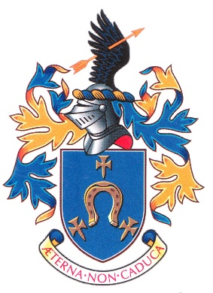

Welcome to St John’s Beaumont.
St John’s is a Jesuit school. It shares a vision for education with, and is part of, a network of eleven Jesuit schools in the UK, 169 Jesuit schools in Europe, and 2,232 Jesuit schools and 186 universities worldwide.
The Jesuits (or Society of Jesus) are a Religious Order within the Catholic Church who have long been involved in education. We have two Jesuits at St John’s.
This Shared Vision course is intended to introduce you to Jesuit education and invites you to share in the Jesuit vision for education. The course consists of five sessions, delivered over the course of your first year at St John’s.
We hope you find it helpful in understanding the identity and mission of the school, the 450-year old global tradition of which it is part, and the person and spirit of the founder of the Jesuits and Jesuit schools, St Ignatius of Loyola.
The materials you will be given over the course of Shared Vision will, we hope, build up into a useful resource for understanding and playing your full part in the tradition of Jesuit education at St John’s. Please bring this pack with you to each session.
Welcome.

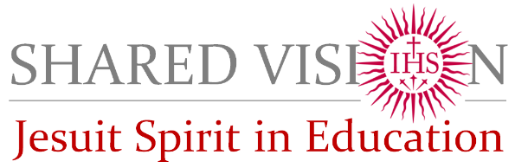

Shared Vision Induction (SVi) is a school-based course of five sessions which explore the identity and mission of Jesuit schools:
Session 1 – Catholic Education & Jesuit Schools
An introduction to Catholic schools and how and why the Catholic church is involved in education. And how Jesuit schools are part of the Catholic church’s work in education.
Session 2 – Meet Ignatius
An introduction to Ignatius of Loyola (1491-1556), founder of the Society of Jesus (the Jesuits) and of Jesuit schools and universities.
Session 3 – Jesuit Mission in Education
An introduction to the vision of Jesuit education as “improvement in living and learning” and how this is articulated in the Jesuit Pupil Profile.
Session 4 – St John’s Beaumont, A Jesuit School
A more detailed look at how SJB has developed as a Jesuit school and how it tries to continue the work of Jesuit education today.
Session 5 – The Spirit of Jesuit Education
A look at Jesuit education in the eleven Jesuit schools in Britain: their Ignatian identity, Christian mission, and Catholic community.

Once you have completed SVi in school, there are two residential courses to which you will be invited in subsequent years: Shared Vision 1 and Shared Vision 2 which help you to explore more deeply the tradition and practice of Jesuit education.
You will also have the opportunity to take part in a retreat – a direct experience of the spirituality of St Ignatius Loyola. This could either be a residential retreat away from school, or a one day retreat in school, or a retreat in daily life spread over a week with short daily sessions and a couple of talks.

